MEDICAL SOCIETY OF THE STATE OF NEW YORK

Certificate of Attendance

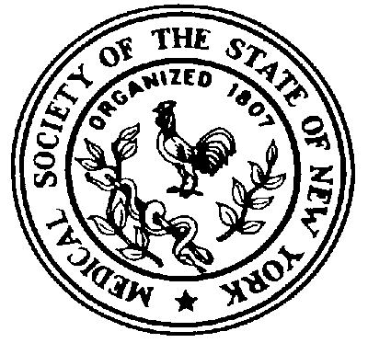

This will serve to verify that (name of participant) attended the CME activity

(Title of Activity)

held on

(Date)

(Name of accredited provider)is accredited by The Medical Society of the State of New York (MSSNY) to provide continuing medical education for physicians.

(Name of accredited provider) designates this (type of activity)activity for a maximum of (number of credits) AMA PRA Category 1 Credits™ Physicians should claim only the credit commensurate with the extent of their participation in the activity

PLEASE RETAIN THIS ATTENDANCE CERTIFICATE AS A RECORD OF YOUR PARTICIPATION

